**CAR STEREO SYSTEM**

**Circuit diagram:**

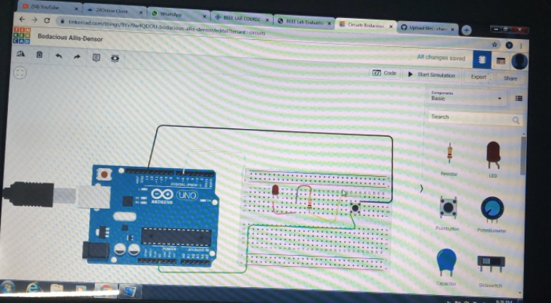

**Theory:-**

**Concept:**

**In my project I used the basic concepts of Brerad board, Arduino, LED.**

**Learning & Observations:**

**I learnt how to use the Bread board, Arduino,& I came to know that how these are working.**

**Problems&Troubleshooting:**

**There are several problems, but after doing several times I had over come them.**

**Pecautions:**

**There will be case of electric shocks,make sure that your hands are not wet.**

**Learnings & Outcomes:**

**I had learnt how to solve& make different circuits using Arduino.**